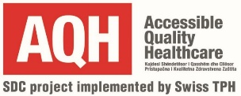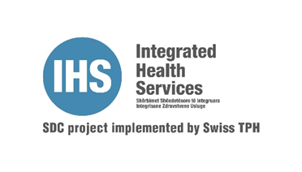

**CONTRACT AWARD NOTICE**

ITT/AQH/IHS/002/2024

**I. CONTRACTING AUTHORITY:**

**Official name**: Swiss Tropical and Public Health Institute - Accessible Quality Healthcare (AQH) Project and Integrated Health Services (IHS) Project in Kosovo

**Postal address**: Rr. Tirana, Prime Residence, C 4/3, Entrance D, 6`th floor, no. 16, 17 & 18, 10000, Pristina, Kosovo.

**Email**: gani.surdulli@aqhproject.org

**II**. **OBJECT OF THE CONTRACT:**

**Contract title:** “Design, layout and printing of promotion materials for AQH and IHS Project needs - ITT/AQH/IHS/002/2024

**Main place of works:** Municipality of Prishtina

**III. AWARD OF CONTRACT:**

**Date of contract award**: 16.10.2024

**Intended date of contract signing:** after 10 days.

**Official name of economic operator to whom the framework agreement is awarded:**

“STUDIO FORMA” O.P.

**Addresses:**

Str: “Ernesto Sabato, area Marigona, 10000 Pristina, Republic of Kosovo

**Total of the bid price:** 3,586.40 Eur

We like to thank all the applicants who responded to this tender activity.

**Date: 16.10.2024**