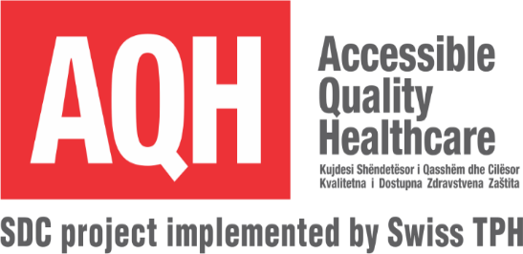
The Accessible Quality Healthcare (AQH) project, funded by the Swiss Agency for Development and Cooperation (SDC), continues to support the implementation of the national health sector reform agenda and complements other donor-supported programmes with a focus on the primary health care level (PHC). The AQH second phase 4-year project aims to stimulate use of quality PHC services by all Kosovo citizens, with particular attention to the needs and inclusion of socially vulnerable populations. The project is implemented by the Swiss Tropical and Public Health Institute.

The project is seeking applicants for the following position:

Communications Officer (Temporary)
Job summary:
Provide support to design, prepare, deliver and evaluate media and communication activities undertaken by the project.
Essential competencies:
Degree in Media and Communication, Public Relations, Journalism or equivalent. Minimum of 3 years’ work experience in the field of communication/media at national and local levels.
Key responsibilities:
- Preparation of project communication materials posters, leaflets, manuals, reports, videos; radio, adverts, newsletters, social media pages etc.
- Assist on development, implementation and monitoring the communication strategies for project activities
- Monitoring and evaluation of communication activities and preparation of high quality reports in English as requested
- Support municipality stakeholders to implement communication activities related to the project activities
- Assist stakeholders (municipalities/NGOs) to organise community-based communication events
- Organise AQH media events, coordinating with Ministry of Health and municipality communication staff as appropriate
- Produce media briefing materials and assist with translation of project materials as required
- Develop content for the websites supported by the project and ensure that the sites are kept up-to-date in 3 languages
- Maintain AQH project social media pages
- Provide communication materials for the donor agency and consortium partners, as well as other professional networks
- Ensure that all published materials meets the corporate identity standards of the AQH project and SDC
Key competencies:
- Previous experience as a Communication Expert in the not-for-profit sector is highly desirable
- Knowledge of Social and Behaviour Change Communication principles is highly desirable
- Excellent written and oral skills in English and Albanian. Serbian language skills are desirable
- High-level expertise in producing quality communication materials is essential
- Extensive experience of organising media/communication events at national and local levels (Project launches, community-based events etc.)
- Demonstrated ability to work in a changing, multi-cultural environment and establish harmonious and effective working relationships and teambuilding; excellent inter-personal skills
- Able to work independently to deadlines, with excellent attention to detail
- Proven experience working with diverse communities, local partners and civil society institutions
- Expertise in using core IT applications, particularly MS Office. Knowledge of media software is desirable
- Full driving license and willingness to travel as required
This is full-time position for 6 months period replacement of a staff member while on maternity leave. The expected starting date is as soon as possible and is open only to national experts.
Qualified applicants should email: 1) Curriculum Vitae; 2) Three references and 3) Cover letter explaining why they are qualified for the position to AQH Administrative Officer shqipe.kabashi@aqhproject.org.
All documents should be in English. Applicants should specify in the subject line the name of the post they apply.
Closing date for submission of applications is 5 February 2021.
Only short-listed applicants will be contacted. Interviews will take place on week commencing 15 February 2021.

